**Ex3 Report**

1. Threshold to stop EM : 1e-3

2.

3. Confusion Matrix:

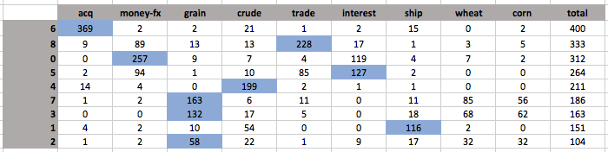

4. Histograms:

5. Accuracy of the model is 77.636%.

6. Parameters:

k = 10

vocabulary size = 6800

lambda = 1

A graph that represents the topics per cluster:

